1. Ten Times

Write a program that prints the important phrase "Mr. Mitchell is cool." on the screen ten times. Use a for loop to do it.

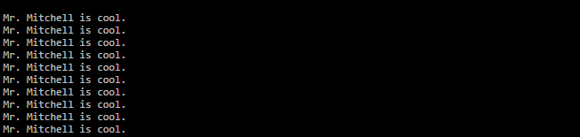

1. Counting Machine

Write a program that gets an integer from the user. Count from 0 to that number. Use a for loop to do it.



Counting Machine Revisited

Write a program that gets three integers from the user. Count from the first number to the second number in increments of the third number. Use a for loop to do it.

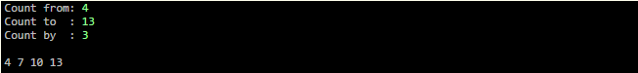

1. Counting By Halves

Write a program that uses a for loop. With the loop, make the variable x go from -10 to 10, counting by 0.5. (This means that x can't be an int.)

